DSA0502 QUERY PROCESSING FOR DATASCIENCE
CO1 AT1 DATA INTERPRETATION

Manisha M
192424130

1. Aim
To read railway reservation data from CSV, JSON, and XML files, merge the train and ticket records, calculate occupancy percentage, identify cancelled tickets, summarize route-wise passenger count, and export the cleaned dataset using Python Pandas.
Description
Railway reservation systems maintain information about trains, passengers, and ticket bookings. In this assignment, data stored in different file formats (CSV, JSON, and XML) is combined into a single dataset. The merged data is cleaned by removing duplicate records and used to analyze train occupancy, cancelled tickets, and passenger statistics for each route.
Tools Used
- Python 3 — pandas, json, xml.etree.ElementTree, matplotlib
- Files: Trains.csv, Tickets.csv, Tickets.json, Tickets.xml

Result
The railway reservation datasets from different file formats were successfully read, merged, analyzed, and cleaned using Python Pandas. The occupancy percentage, cancelled tickets, and route-wise passenger statistics were generated successfully, and the cleaned dataset was exported to a CSV file.

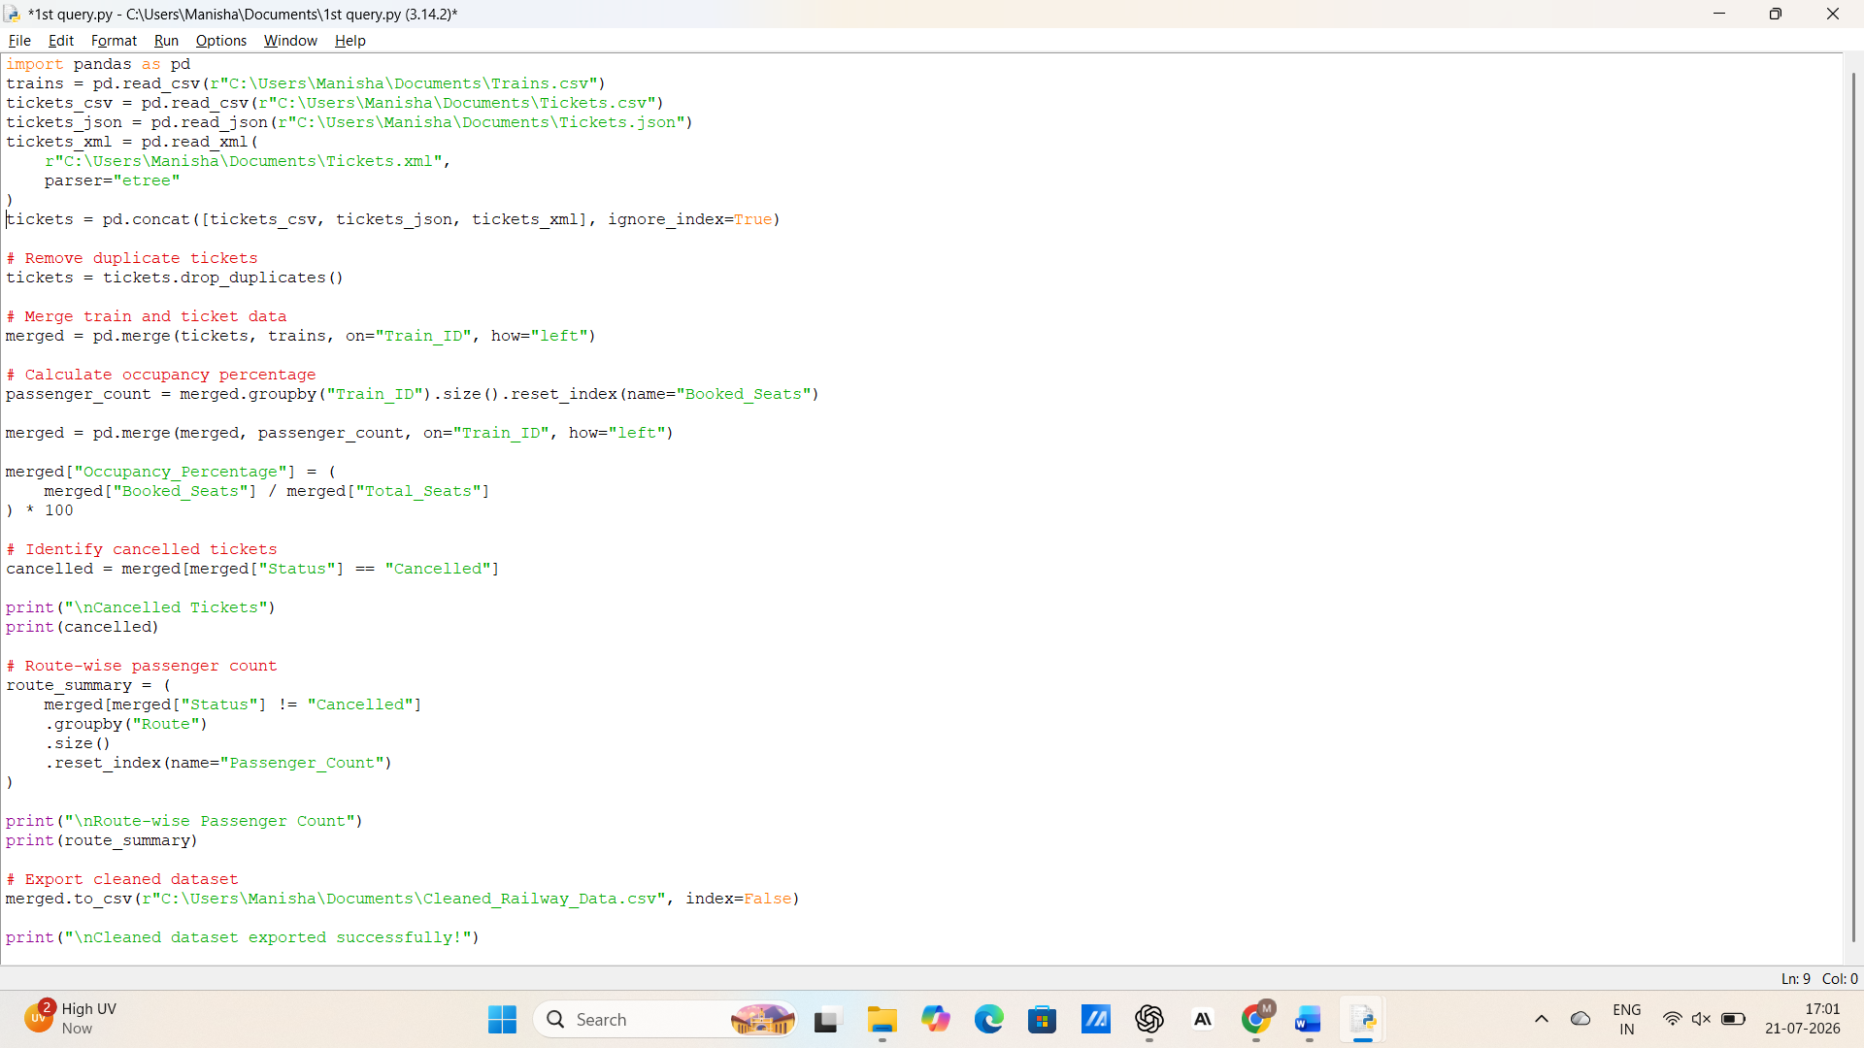

OUTPUT:
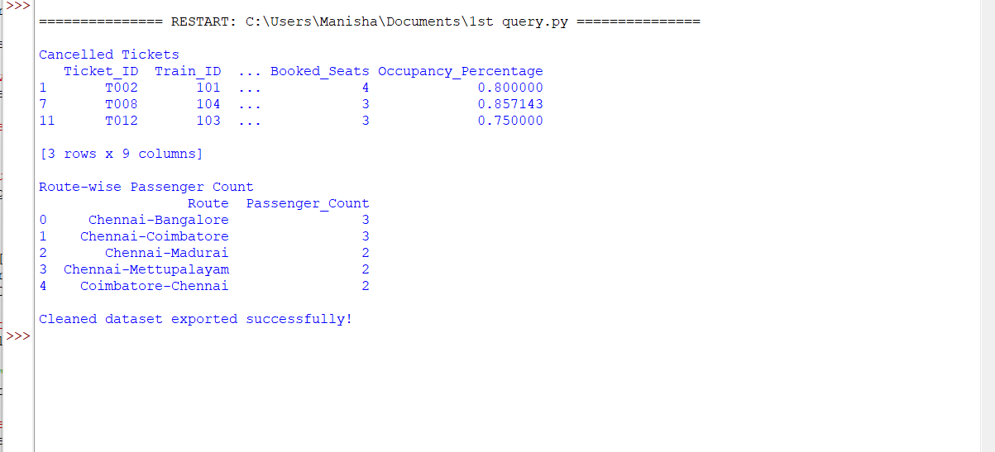

Aim
LIBRARY MANAGEMENT SYSTEM
To read library management datasets from CSV, JSON, and XML files, inspect the datasets, handle missing values, remove duplicate records, validate data types, merge related datasets using a common key, perform aggregation and summary statistics, identify the category with the highest value, and export the cleaned dataset using Python Pandas.

Description
This experiment demonstrates how to process library management data stored in multiple file formats using Python Pandas. The datasets are inspected, cleaned by handling missing values and duplicates, validated for correct data types, merged using a common key (Author_ID), analyzed using aggregation functions, and finally exported as a cleaned CSV file.

Result
The library management datasets were successfully read from multiple formats, cleaned, merged, analyzed, and exported. The category-wise statistics were generated, and the category with the highest total value was identified successfully.

PROGRAM

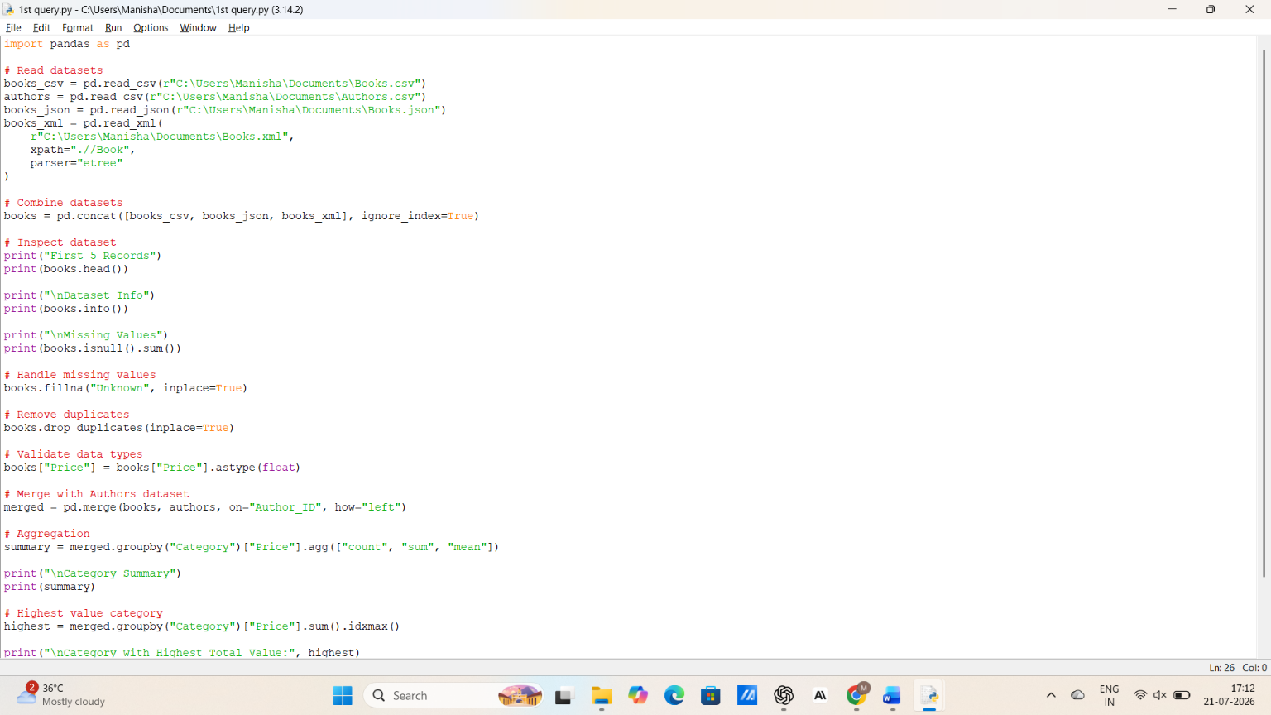

OUTPUT:
